**CHAPTER 1**

**INTRODUCTION**

**1.1 Introduction to Computer Graphics**

**COMPUTER GRAPHICS** is concerned with all aspects of producing pictures or images using a computer. The field began humbly almost 50 years ago, with the display of a few lines on a cathode-ray tube (CRT); now, we can create images by computer that are indistinguishable from photographs of real objects. We routinely train pilots with simulated airplanes, generating graphical displays of a virtual environment in real time. Feature-length movies made entirely by computer have been successful, both critically and financially. Massive multiplayer games can involve tens of thousands of concurrent participants.

VISUALIZATION is any technique for creating images, diagrams or animations to communicate a message.

**1.2 Image Types**

➢ **2D computer graphics:**

2D computer graphics are the computer-based generation of digital images mostly from two-dimensional models, such as 2D geometric models, text, and digital images, and by techniques specific to them.2D computer graphics are mainly used in applications that were originally developed upon traditional printing and drawing technologies, such as typography, cartography, technical drawing, and advertising. Two-dimensional models are preferred, because they give more direct control of the image than 3D computer graphics, whose approach is more akin to photography than to typography.

There are two approaches to 2D graphics: vector and raster graphics.

* Pixel art: Pixel art is a form of digital art, created through the use of raster graphics software, where images are edited on the pixel level.
* Vector graphics: Vector graphics formats are complementary to raster graphics, which is the representation of images as an array of pixels, as it is typically used for the representation of photographic images.

➢ **3D computer graphics:**

With the birth of the workstation computers (like LISP machines, paint box computers and Silicon Graphics workstations) came the 3D computer graphics.3D computer graphics in contrast to 2D computer graphics are graphics that use a three-dimensional representation of geometric data that is stored in the computer for the purposes0 of performing calculations and rendering 2D images.

**1.3 Applications of Computer Graphics**

Some of the applications of computer graphics are listed below:

* Computational biology
* Computational physics
* Computer-aided design
* Computer simulation
* Digital art
* Education
* Graphic design
* Video Games
* Virtual reality
* Web design

**1.4 Introduction to OpenGL**

As a software interface for graphics hardware, OpenGL's main purpose is to render two- and three-dimensional objects into a frame buffer. These objects are described as sequences of vertices (which define geometric objects) or pixels (which define images). OpenGL performs several processing steps on this data to convert it to pixels to form the final desired image in the frame buffer.

**Basic OpenGL Operation**

The figure shown below gives an abstract, high-level block diagram of how OpenGL processes data. In the diagram, commands enter from the left and proceed through what can be thought of as a processing pipeline. Some commands specify geometric objects to be drawn, and others control how the objects are handled during the various processing stages.

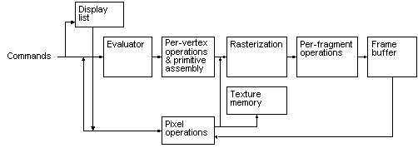

**Fig 1.1:** Basic OpenGL Operation.

**1.5 Introduction to GLUT**

GLUT is the OpenGL Utility Toolkit, a window system independent toolkit for writing OpenGL programs. It implements a simple windowing application programming interface (API) for OpenGL. GLUT makes it considerably easier to learn about and explore OpenGL programming. GLUT provides a portable API so you can write a single OpenGL program that works on both Win32 PCs and X11 workstations.

GLUT is designed for constructing small to medium sized OpenGL programs. While GLUT is well-suited to learning OpenGL and developing simple OpenGL applications, GLUT is not a full-featured toolkit so large applications requiring sophisticated user interfaces are better off using native window system toolkits like Motif. GLUT is simple, easy, and small. My intent is to keep GLUT that way.

**The GLUT library supports the following functionality:**

* Multiple windows for OpenGL rendering.
* Call back driven event processing.
* An `idle' routine and timers.
* Utility routines to generate various solid and wire frame objects.
* Support for bitmap and stroke fonts.
* Miscellaneous window management functions.

**1.6 Overview of the project**

OpenGL is a software interface to graphics hardware. This interface consists of about 150 distinct commands that you use to specify the objects and operations needed to produce interactive three-dimensional applications. This project, named DYNAMIC SORTING ALOGRITHM VISUALIZER uses OpenGL software interface and develops visuals on sorting processes. This project uses the techniques like basic geometric primitives, color functions, bit character functions and many other functions for displaying, translation and scaling of visual bars. This project emphasizes on using various functions that are available in openGL like transpose, polygon and many more.

**1.7 Aim of the project**

The aim of this project is to create a visualization of sorting techniques. The program sorts the randomized numbers based on the sorting technique selected by user and displays the sorting process on window.

**CHAPTER 2**

**SOFTWARE REQUIREMENT SPECIFICATION**

**2.1 Software Requirements**

➢ Operating System : Windows 98/XP or Higher

➢ Programming Language : C,C++

➢ CodeBlocks 13.17 or higher: This Software package contains the required libraries to support C++ language.

➢ Toolkit : GLUT Toolkit

**2.2 Hardware Requirements**

This package has been developed on:

➢ Processor : Pentium Processor

➢ Processor Speed : 333 MHz

➢ RAM : 32 MB or Higher

➢ Graphics Card : 512MB

➢ Monitor : Color

➢ Keyboard : Low Profile, Dispatch able Type

➢ I/O Parts : Monitor

**CHAPTER 3**

**DESIGN**

**3.1 Initialization**

Initialize the interaction with the windows. Initialize the display mode, double buffer and depth buffer. Initialize the various callback functions for drawing and redrawing arrows and target blocks, for keyboard interface. Initialize the window position and size and create the window to display the output.

**3.2 Flow of control**

The flow of control in the flowchart is with respect to the Dynamic Sorting Algorithm Visualizer. For any program flowchart is compulsory to understand the program. We consider the flowchart for the program for which the flow starts from the start and proceeds to the main function after which it comes to the initialization of callback functions and further it proceeds to the Splash Screen where we have to press enter key to start the menu page, next user has to choose from many options to perform desired operation using keyboard keys. Finally the flow comes to quit which is the end of the flowchart.

**3.3 Flowchart**

If yes

If yes

If yes

If yes

If yes

If Other Key Pressed

Initialization of callback functions

main

If Other Key Pressed

**Fig 3.1:** Flowchart for Dynamic Sorting Algorithm Visualizer program.

Keyboard input

Keyboard input

Event

esc key pressed

p key pressed

r key pressed

c key pressed

S key pressed

Display Menu

If Enter Key Pressed

Display Splash Screen

**CHAPTER 4**

**IMPLEMENTATION**

**4.1 OpenGL Functions**

The various functions used in implementing this project are:

* **glutInit(&argc,argv)**
  + This function is used to initialize glut.
* **glutInitDisplayMode()**
  + This function is used to initialize a display mode for the screen. It can choose one of the following constant values as it’s parameters:
    - GLUT_SINGLE
    - GLUT_RGB
    - GLUT_DOUBLE
* **glutInitWindowPosition()**
  + This function is used to set the position of the top left corner of the window. It takes in 2 integer values as input parameters which are the coordinates specified for the position for the top left corner of the window.
* **glutInitWindowSize()**
  + This function is used to specify the size of the created window, inside which the scene will be generated. It takes in two integer parameters, the width and height of the window.
* **glutCreateWindow()**
  + This function creates the window with the specified dimensions and position and assigns the string parameter passed to it as the name of the window.
* **glutMainLoop()**
  + This function is called at most once in a GLUT program. Once called, this routine will never return. It will call as necessary, any callbacks required for the program.
* **glBegin()**
  + This function is used in drawing the basic primitives like lines, points, polygons and quads. It takes in a constant value which specifies the primitive to be drawn. Some of the parameters it can have are:
    - GL_POLYGON
    - GL_LINES
    - GL_LINE_LOOP
    - GL_QUADS
    - GL_QUAD_STRIP
* **glClear()**
  + This function is used to clear the contents of the buffer passed as the parameter to this function, onto the screen.
  + It takes a constant value as a parameter like:
    - GL_CLEAR_BUFFER_BIT
    - GL_DEPTH_BUFFER_BIT
* **glClearColor()**
  + This function takes in four floating values:
    - Red
    - Green
    - Blue
    - Alpha
  + Based on RGB values, the color is decided. The Alpha value gives the degree of transparency of the color.
  + The values for RGBA will range from 0.0 to 1.0
* **glEnd()**
  + This function works with the glBegin() function. It marks the end of all the vertices to be used for drawing the primitive.
* **glVertex2x()**
  + This function is used to take in the coordinates of a vertex in a geometric primitive. For integer values, the placeholder ‘x’ is ‘i’ while for floating values, ‘x’ is’d’.
* **glutTimerFunc (unsigned int msec, void (*func)(int value), value)**
  + This function registers the timer callback func to be triggered in at least msec milliseconds. The value parameter to the timer callback will be the value parameter to glutTimerFunc.
* **glutBitmapCharacter(void *font, int character)**
  + This function renders the characters in the named bitmap font. Some of the fonts available are:
    - GLUT_BITMAP_8_BY_13
    - GLUT_BITMAP_TIMES_ROMAN_10
    - GLUT_BITMAP_HELVETICA_18

**CHAPTER 5**

**TESTING**

**Test Cases**

|  |  |  |  |
| --- | --- | --- | --- |
| **Insert for Test Case** | **Expected Output** | **Observed Output** | **Remarks** |
| s KEY | It should start the sorting of the number represented as bars of varying height using selected algorithm. | It sorts the number using sorting algorithm selected. | Pass. |
| c KEY | It should display different sorting algorithms available | It displays different sorting algorithms. | Pass. |
| r KEY | It should display new randomized numbers in the form of bars of varying height. | It randomizes and displays the numbers in bars of varying height. | Pass |
| p KEY | It should pause the sorting process when pressed. | It stops the sorting process. | Pass |
| ESC KEY | It should close the program. | The program closes. | Pass. |

**Fig 5.1:** Testing

**CHAPTER 6**

**RESULTS**

The program starts with a splash screen which greets the user. The Screen displays the title of our project. The screen prompts the user to press Enter key to continue to the next screen. This screen is used to enhance the look and feel of the application to make it visually appealing.

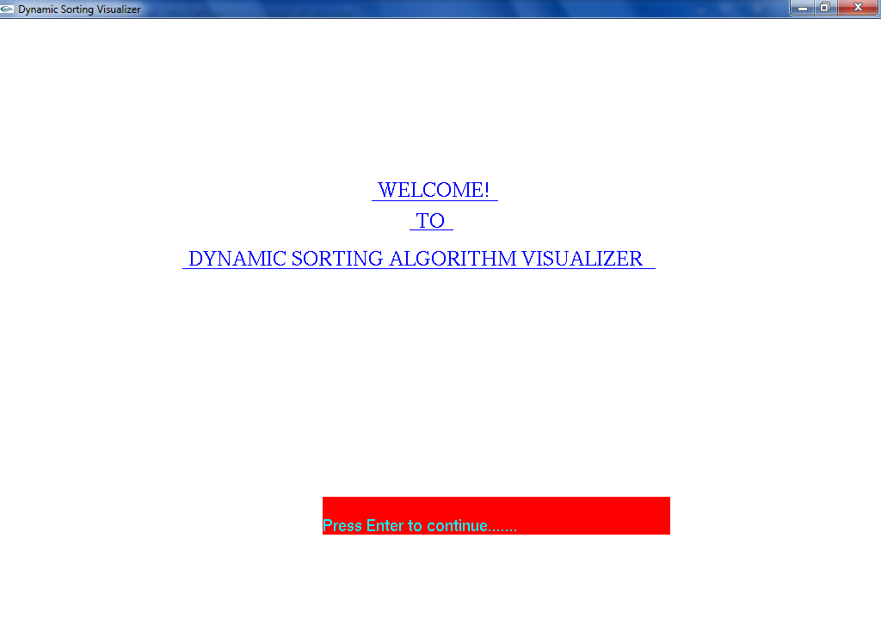

**Fig 6.1:** Display of the Splash Screen

This is the first scene which appears when the program is executed. The display prompts the user to press Enter key. The content is displayed with the help of the following function:

1. front(): This function displays the Greetings to user and also displays the name of the program.
2. bitmap_output(): This is a user defined function which helps to display the text on screen at desired position.

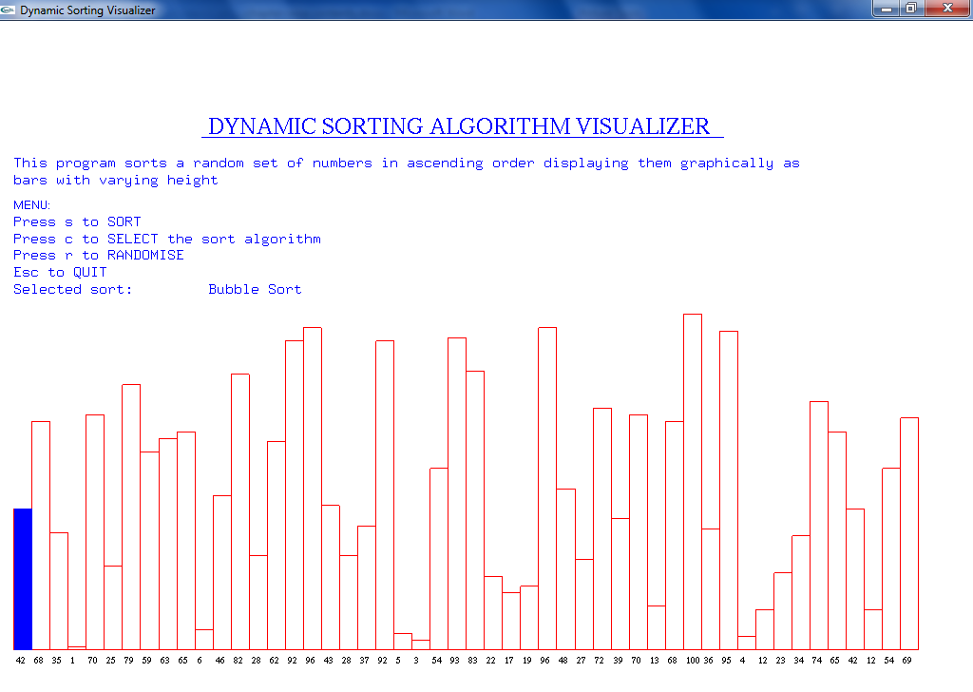

**Fig 6.2:** Display of the Menu Screen

This is the screen which appears when the user presses Enter key on Splash Screen. The action menu is displayed with the help of the following functions

1. display_text(): This function displays the whole menu and also displays the randomized numbers in the form of bars of varying height.
2. bitmap_output(): This is a user defined function which helps to display the text on screen at desired position.
3. int_str(): This is a user defined function which converts the character value to integer value.

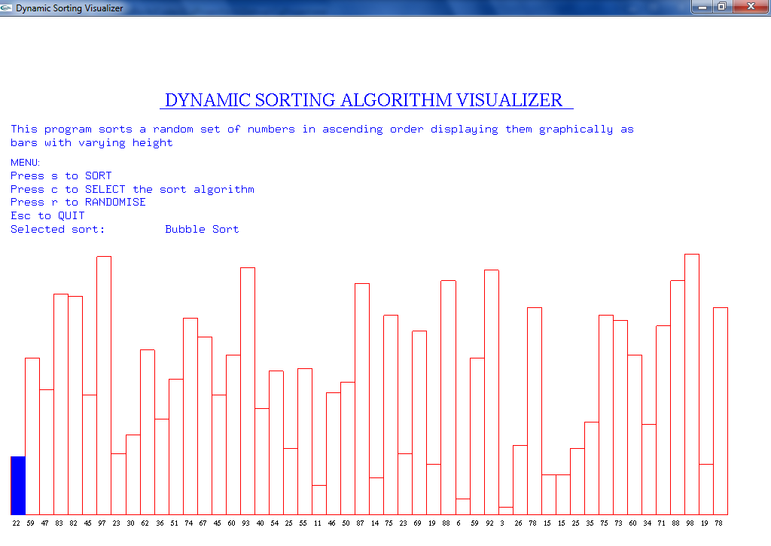

**Fig 6.3:** Sort Algorithms

On pressing the “c” key the user can change the sort algorithm which he wants to use for performing the sort on randomized numbers.

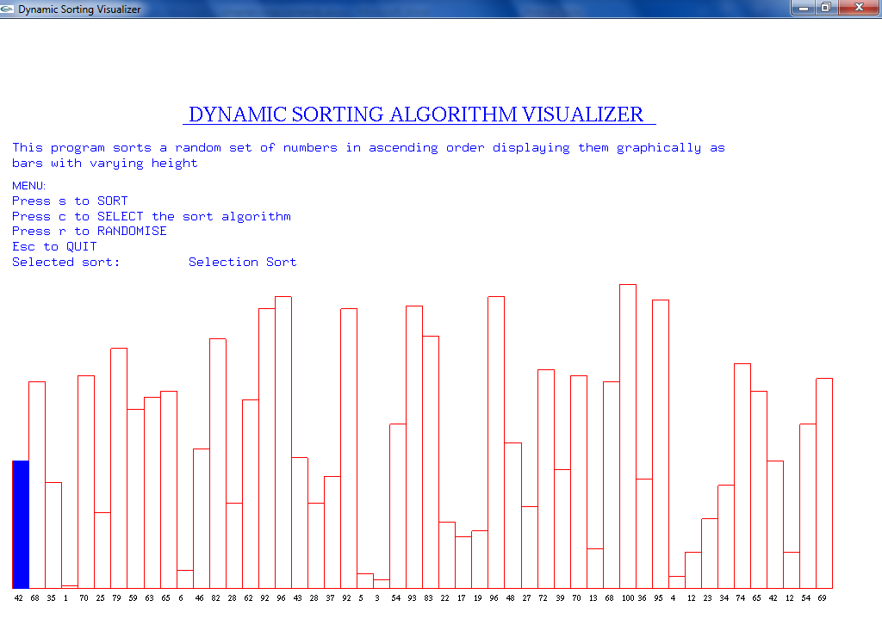

**Fig 6.4:** Randomize the number bars

On pressing the “r” key the user can randomize the number that are to be used by algorithm for sorting. On pressing this key changes the height of the bars representing the numbers.



**Fig 6.5:** Sorting

On pressing the “s” key, the user can perform the sorting on the numbers using selected sorting algorithm. The sorting process is visualized as the numbers are shifted from one position to other.



**Fig 6.6:** Bubble Sort Input

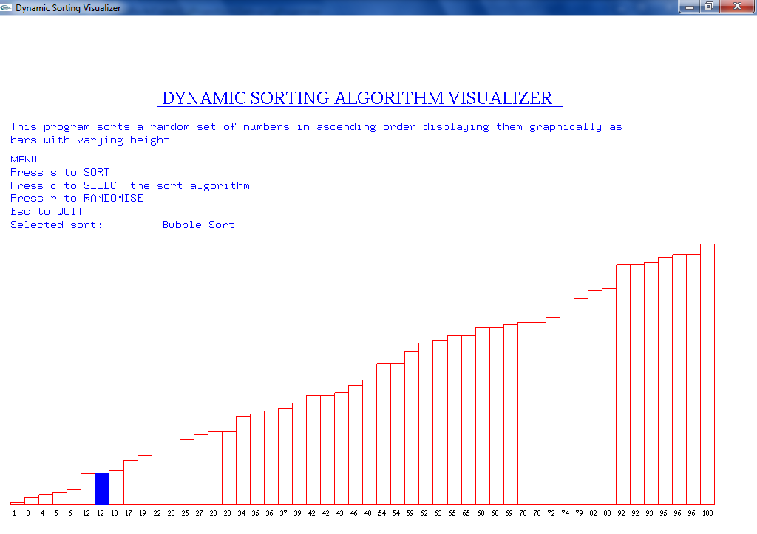

**Fig 6.7:** Bubble Sort Output

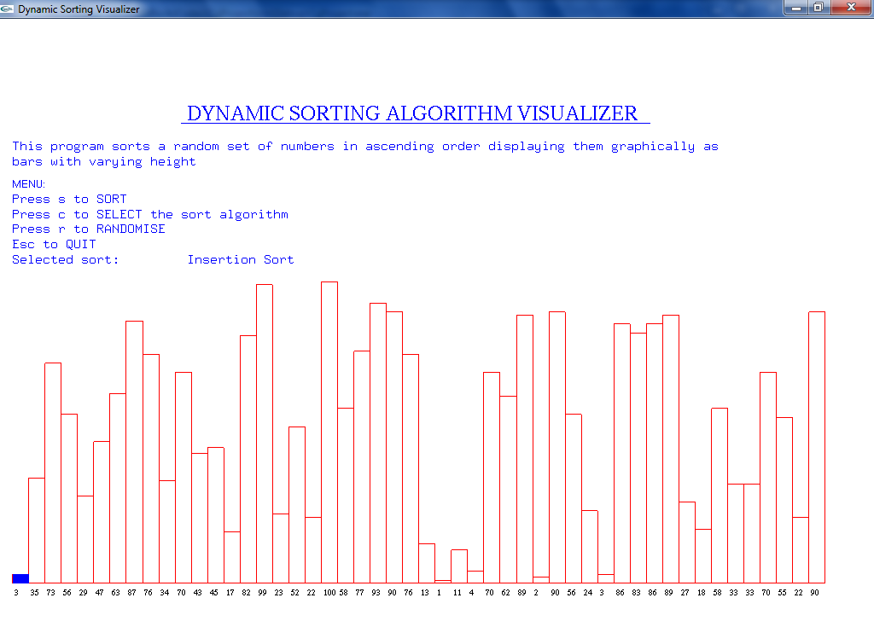

**Fig 6.8:** Insertion Sort Input

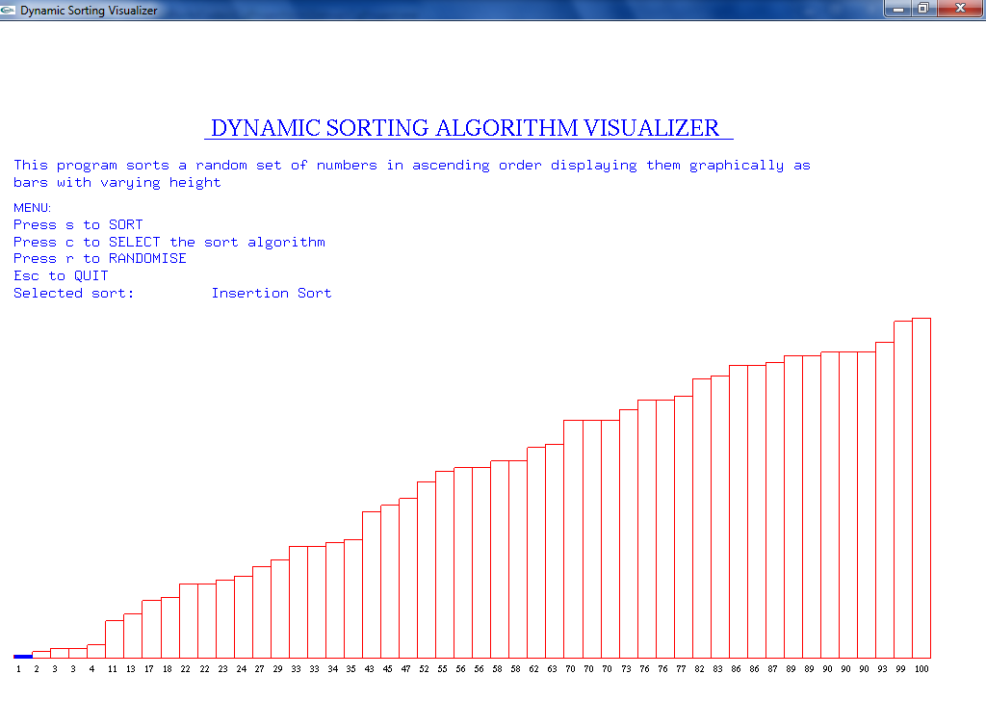

**Fig 6.9:** Insertion Sort Output

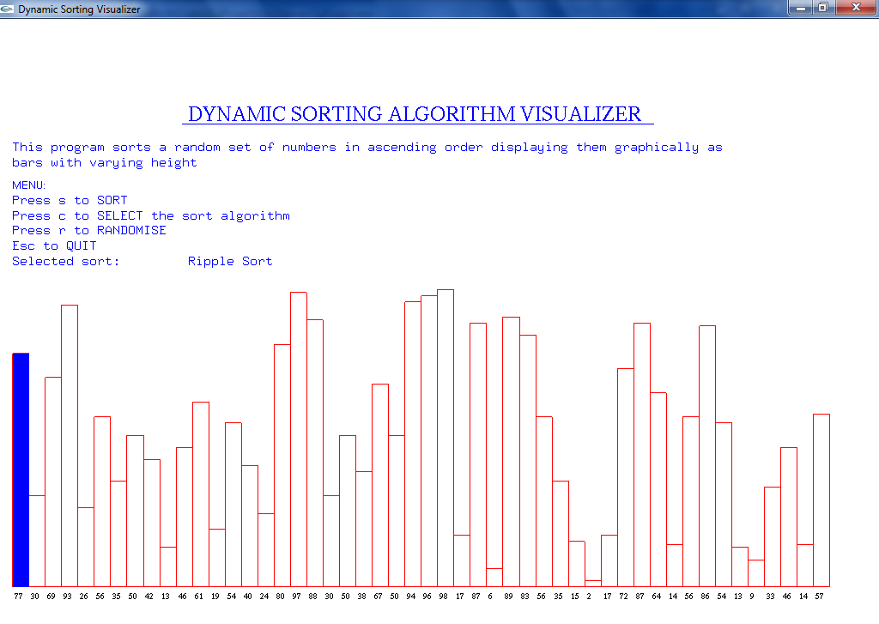

**Fig 6.10:** Ripple Sort Input

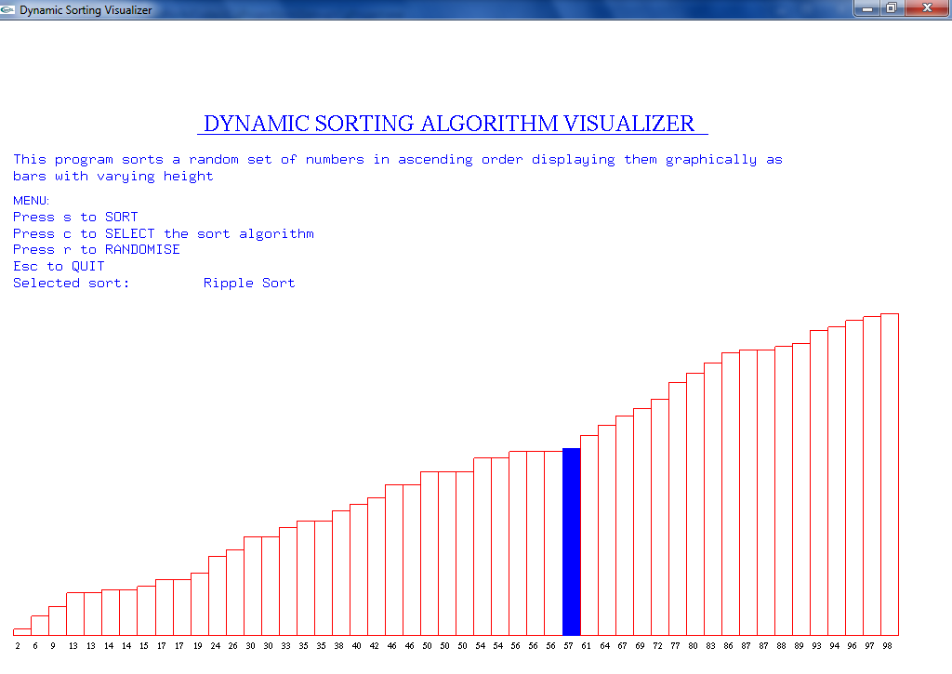

**Fig 6.11:** Ripple Sort Output

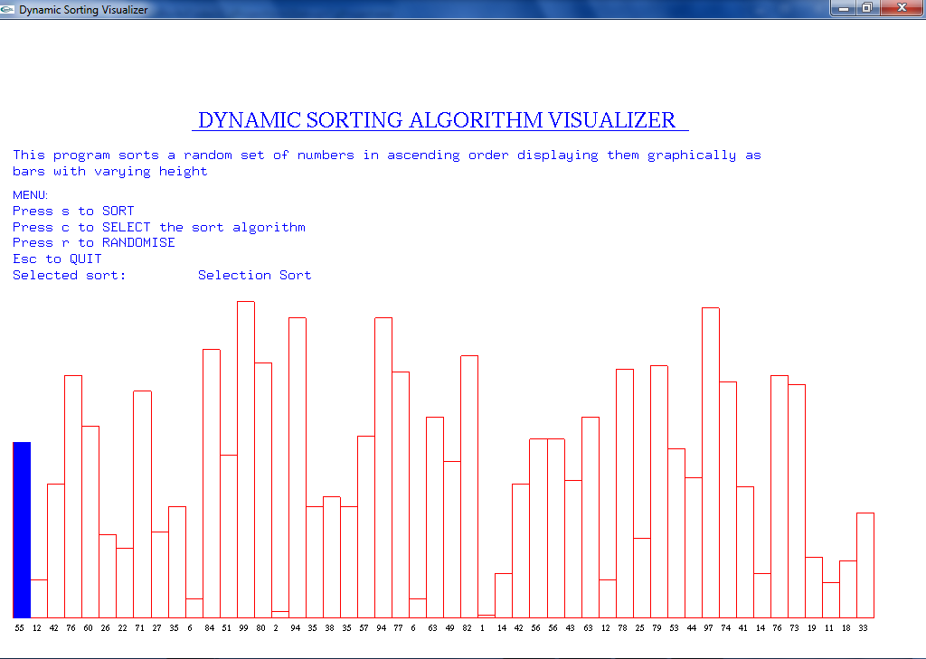

**Fig 6.12:** Selection Sort Input

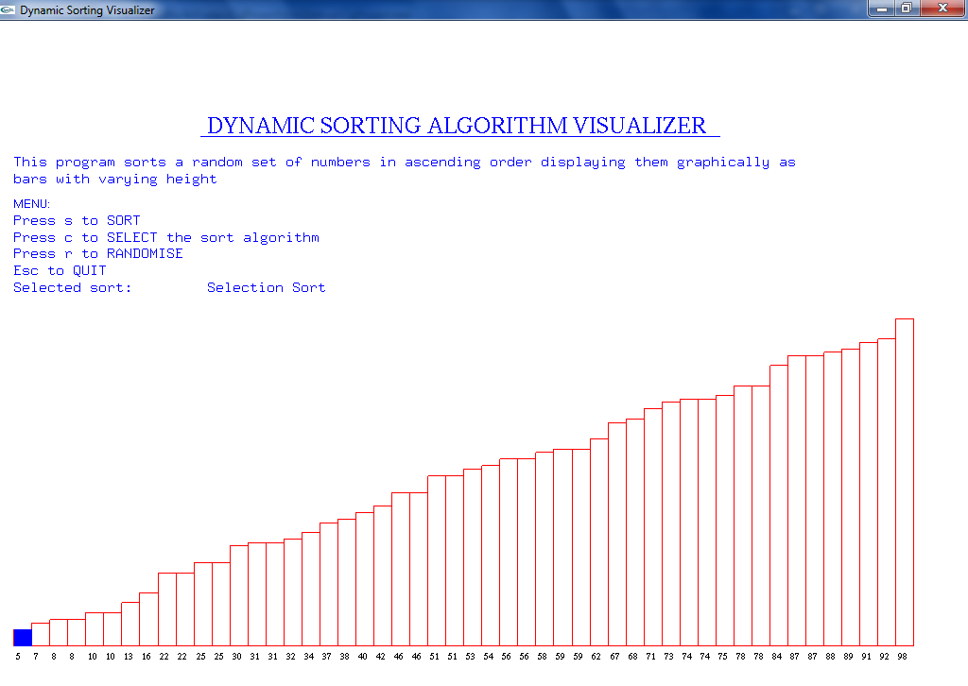

**Fig 6.13:** Selection Sort Output

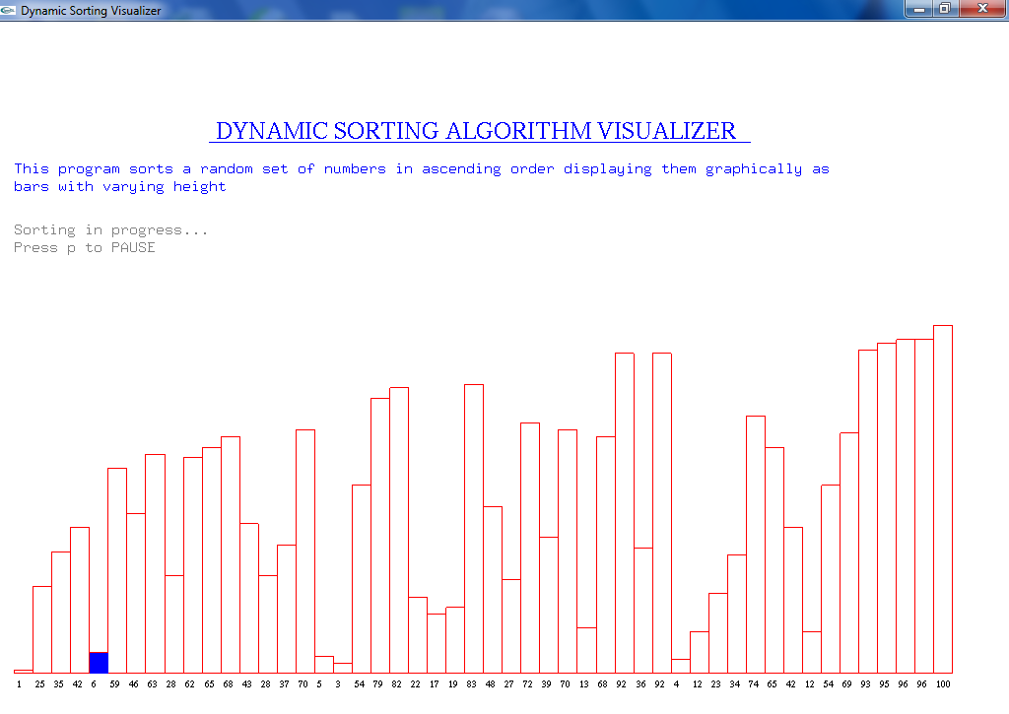

**Fig 6.14:** Pause

On pressing the “p” key the sorting process is halted. The user gets the main menu to select from different options. The sorting process can be resumed by pressing “s” Key.

The user can quit the program by pressing “ESC” Key.

**Conclusion**

## We are able to visualize the Sorting Algorithms with the help of OpenGL Programming using glut in C/C++. The program used the various functions provided by OpenGL to create a 2D visuals. With the help of keyboard, the user can select from various options available on the window. Every aspiring engineering student wants to understand the working of sorting algorithms in detail as it helps them in solving the real world problems. We are able to visualize the Sorting Algorithms with the help of OpenGL Programming using glut in C/C++. This helps in visualize the working of various algorithms and to help understand the inner working process in algorithm.

**References**

[1]. Edward Angel *“Interactive Computer Graphics”* Pearson Education, 5th Edition.2008

[2]. Donald Hearn & Pauline baker *“Computer Graphics with OpenGL”* 3rd Edition. 2011

[3].[www.opengl.org](http://www.opengl.org)

[4]. [www.freeglut.sourcefourge.net](http://www.freeglut.sourcefourge.net)

[5]. [www.github.com](http://www.github.com)

[6]. [www.openglcg.blogspot.in](http://www.openglcg.blogspot.in)